## horizontal line

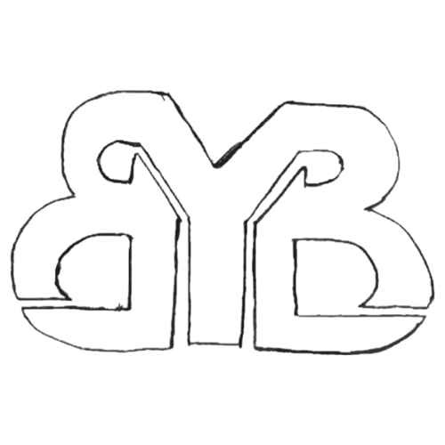

Bow Mar Young Businesses

Business Proposal

**─**

Your First and Last Name (Include all names if more than one entrepreneur involved):

Your Company Name:

Your Product or Service:

# Overview

Use this questionnaire to help you create a business plan that is thoughtful and clear. Creating a business takes a lot of time and often requires some fine tuning. The judges look forward to hearing your business plan and are happy to provide useful feedback so that you can be prepared to sell your items this summer! Come with an open mind ready to learn and have fun.

# Available Dates to Sell :

Do you prefer to attend the market on July 13 or August 17?

# Product Description:

Business Name:

Describe your product:

What are you selling and why?

# Marketing:

Describe your target market- who are you selling to?

Why will people want to buy your product/service?

How will you make your product/service and table stand out at the market?

# Finances:

How much does it cost to make your product or provide your service?

What do you need to create your product/service?

How many items do you think you can sell?

If you sell all of your items, what will your total revenue and profit be?

# Operations:

When will you work on your business?

How much time does it take to create your product/service?

What possible problems could you face and prepare ahead of time for?

What value will you bring to the market?